**Basics of Hash Tables**

**Q:**When I use an object as a key in a Hashtable , what in the Object class must I override and why?

**A:**When you create your own key object for use in a Hashtable, you must override the [Object.equals()](http://www.javaworld.com/" \l "resources) and [Object.hashCode()](http://www.javaworld.com/" \l "resources) methods since Hashtable uses a combination of the key's hashCode() and equals() methods to store and retrieve its entries quickly. It's also a general rule that when you override equals(), you always override hashCode().

## More on why

A slightly more in-depth explanation will help you understand Hashtable's mechanism for storage and retrieval. A Hashtable internally contains buckets in which it stores the key/value pairs. The Hashtable uses the key's hashcode to determine to which bucket the key/value pair should map.

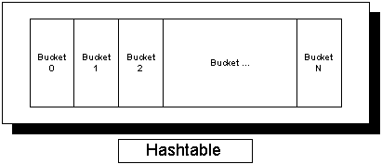Figure 1. A Hashtable and its buckets

Figure 1 shows a Hashtable and its buckets. When you pass a key/value to the Hashtable, it queries the key's hashcode. The Hashtable uses that code to determine the bucket in which to place the key/value. So, for example, if the hashcode equals zero, the Hashtable places the value into Bucket 0. Likewise, if the hashcode is two, the Hashtable places the value into Bucket 2. (This is a simplistic example; the Hashtable will massage the hashcode first so the Hashtable doesn't try to insert the value outside the bucket.)

By using the hashcode this way, the Hashtable can also quickly determine in which bucket it has placed the value when you try to retrieve it.

Hashcodes, however, represent only half the picture. The hashcode only tells the Hashtable into which bucket to drop the key/value. Sometimes, however, multiple objects may map to the same bucket, an event known as a collision. In Java, the Hashtable responds to a collision by placing multiple values into the same bucket (other implementations may handle collisions differently). Figure 2 shows what a Hashtable might look like after a few collisions.

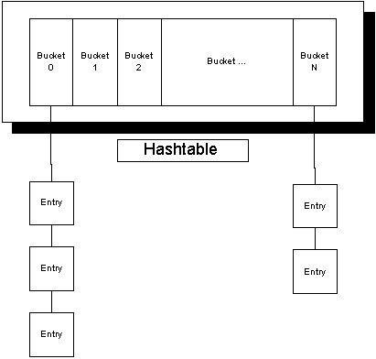Figure 2. A Hashtable after a few collisions

Now imagine that you call get() with a key that maps to Bucket 0. The Hashtable will now need to peform a sequential search through the key/value pairs in Bucket 0 to find your requested value. To perform this lookup, the Hashtable executes the following steps:

1. Query the key's hashcode
2. Retrieve the list of key/values residing in the bucket given by the hashcode
3. Scan through each entry sequentially until a key that equals the key passed into get() is found

A long answer to a short question I know, but it gets worse. Properly overriding equals() and hashCode() is a nontrivial exercise. You must take extreme care to guarantee both methods' contracts.

## On implementing equals()

According to the equals() Javadoc, the method must conform to the following rules:

"The equals() method implements an equivalence relation:

* It is reflexive: For any reference value x, x.equals(x) should return true
* It is symmetric: For any reference values x and y, x.equals(y) should return true if and only if y.equals(x) returns true
* It is transitive: For any reference values x, y, and z, if x.equals(y) returns true and y.equals(z) returns true, then x.equals(z) should return true
* It is consistent: For any reference values x and y, multiple invocations of x.equals(y) consistently return true or consistently return false, provided no information used in equals comparisons on the object is modified
* For any non-null reference value x, x.equals(null) should return false"

In [*Effective Java*](http://www.javaworld.com/#resources), Joshua Bloch offers a five-step recipe for writing an effective equals() method. Here's the recipe in code form:

**public** **class** **EffectiveEquals** {

**private** **int** valueA;

**private** **int** valueB;

. . .

**public** **boolean** equals( **Object** o ) {

**if**(**this** == o) { *// Step 1: Perform an == test*

**return** **true**;

}

**if**(!(o **instanceof** **EffectiveEquals**)) { *// Step*

2: **Instance** of check

**return** **false**;

}

**EffectiveEquals** ee = (**EffectiveEquals**) o; *//*

**Step** 3: **Cast** argument

*// Step 4: For each important field, check to*

see **if** they are equal

*// For primitives use ==*

*// For objects use equals() but be sure to also*

*// handle the null case first*

**return** ee.valueA == valueA &&

ee.valueB == valueB;

}

. . .

}

**Note:** You need not perform a null check since null instanceof EffectiveEquals will evaluate to false.

Finally, for Step 5, go back to equals()'s contract and ask yourself if the equals() method is reflexive, symmetric, and transitive. If not, fix it!

## On implementing hashCode()

For hashCode()'s general contract, the Javadoc says:

* "Whenever it is invoked on the same object more than once during an execution of a Java application, the hashCode() method must consistently return the same integer, provided no information used in equals comparisons on the object is modified. This integer need not remain consistent from one execution of an application to another execution of the same application.
* If two objects are equal according to the equals(Object) method, then calling the hashCode() method on each of the two objects must produce the same integer result.
* It is not required that if two objects are unequal according to the equals(java.lang.Object method, then calling the hashCode() method on each of the two objects must produce distinct integer results. However, the programmer should be aware that producing distinct integer results for unequal objects may improve the performance of hashtables."

Creating a properly working hashCode() method proves difficult; it becomes even more difficult if the object in question is not immutable. You can calculate a hashcode for a given object in many ways. The most effective method bases the number upon the object's fields. Moreover, you can combine these values in various ways. Here are two popular approaches:

* You can turn the object's fields into a string, concatenate the strings, and return the resulting hashcode
* You can add each field's hashcode and return the result

While other, more thorough, approaches exist, the two aforementioned approaches prove the easiest to understand and implement.

Tony Sintes is an independent consultant and founder of First Class Consulting, a consulting firm that specializes in bridging disparate enterprise systems and training. Outside of First Class Consulting, Tony is an active freelance writer, as well as author of Sams Teach Yourself Object-Oriented Programming in 21 Days (Sams, 2001; ISBN: 0672321092).

Hashing is a technique that is used to uniquely identify a specific object from a group of similar objects. Some examples of how hashing is used in our lives include:

* In universities, each student is assigned a unique roll number that can be used to retrieve information about them.
* In libraries, each book is assigned a unique number that can be used to determine information about the book, such as its exact position in the library or the users it has been issued to etc.

In both these examples the students and books were hashed to a unique number.

Assume that you have an object and you want to assign a key to it to make searching easy. To store the key/value pair, you can use a simple array like a data structure where keys (integers) can be used directly as an index to store values. However, in cases where the keys are large and cannot be used directly as an index, you should use *hashing*.

In hashing, large keys are converted into small keys by using **hash functions**. The values are then stored in a data structure called **hash table**. The idea of hashing is to distribute entries (key/value pairs) uniformly across an array. Each element is assigned a key (converted key). By using that key you can access the element in **O(1)** time. Using the key, the algorithm (hash function) computes an index that suggests where an entry can be found or inserted.

Hashing is implemented in two steps:

1. An element is converted into an integer by using a hash function. This element can be used as an index to store the original element, which falls into the hash table.
2. The element is stored in the hash table where it can be quickly retrieved using hashed key.

hash = hashfunc(key)  
index = hash % array_size

In this method, the hash is independent of the array size and it is then reduced to an index (a number between 0 and array_size − 1) by using the modulo operator (%).

**Hash function**  
A hash function is any function that can be used to map a data set of an arbitrary size to a data set of a fixed size, which falls into the hash table. The values returned by a hash function are called hash values, hash codes, hash sums, or simply hashes.

To achieve a good hashing mechanism, It is important to have a good hash function with the following basic requirements:

1. Easy to compute: It should be easy to compute and must not become an algorithm in itself.
2. Uniform distribution: It should provide a uniform distribution across the hash table and should not result in clustering.
3. Less collisions: Collisions occur when pairs of elements are mapped to the same hash value. These should be avoided.

**Note**: Irrespective of how good a hash function is, collisions are bound to occur. Therefore, to maintain the performance of a hash table, it is important to manage collisions through various collision resolution techniques.

***Need for a good hash function***

Let us understand the need for a good hash function. Assume that you have to store strings in the hash table by using the hashing technique {“abcdef”, “bcdefa”, “cdefab” , “defabc” }.

To compute the index for storing the strings, use a hash function that states the following:

The index for a specific string will be equal to the sum of the ASCII values of the characters modulo 599.

As 599 is a prime number, it will reduce the possibility of indexing different strings (collisions). It is recommended that you use prime numbers in case of modulo. The ASCII values of a, b, c, d, e, and f are 97, 98, 99, 100, 101, and 102 respectively. Since all the strings contain the same characters with different permutations, the sum will 599.

The hash function will compute the same index for all the strings and the strings will be stored in the hash table in the following format. As the index of all the strings is the same, you can create a list on that index and insert all the strings in that list.

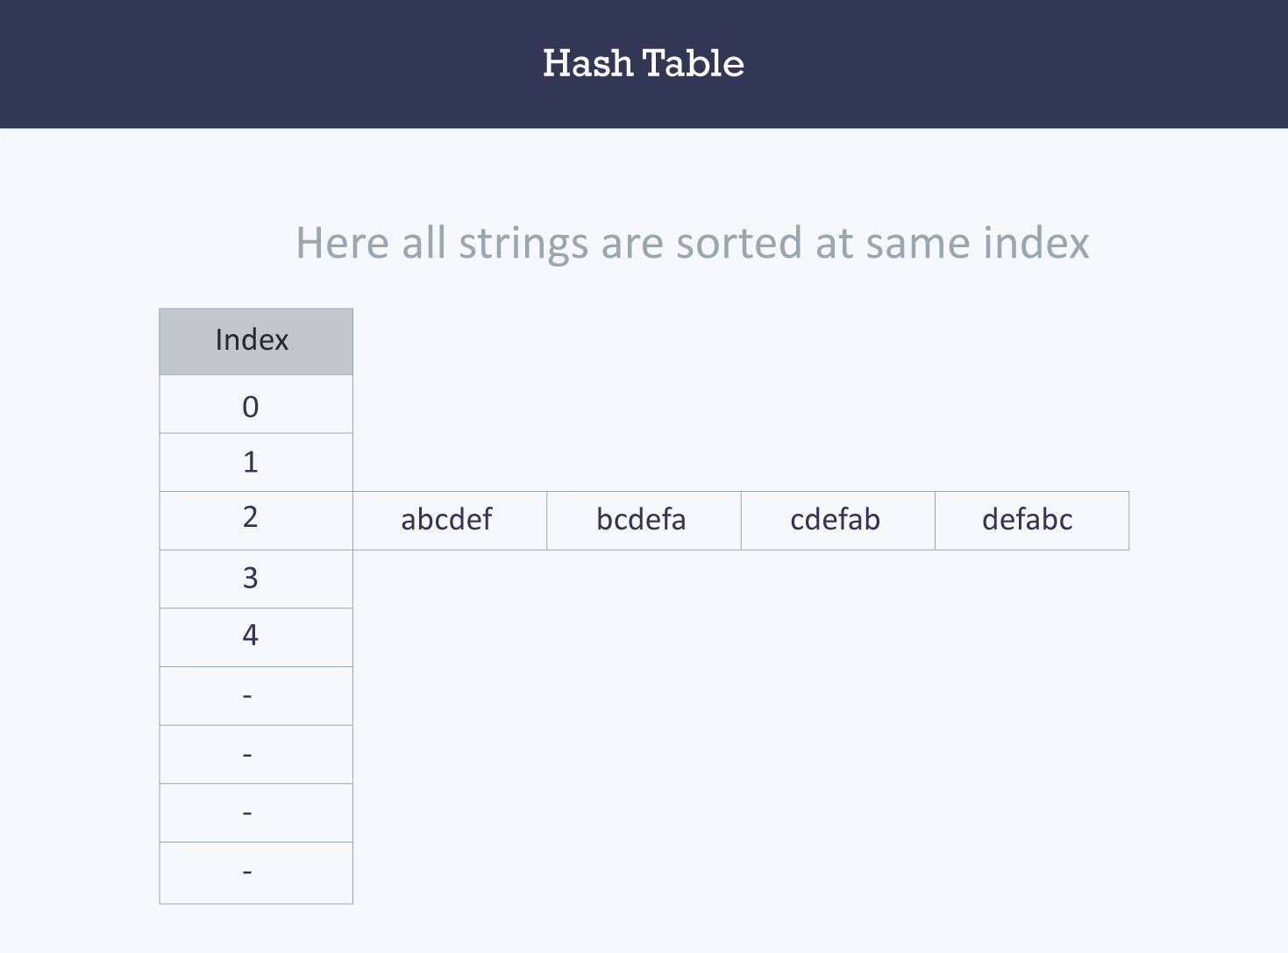

Here, it will take **O(n)** time (where n is the number of strings) to access a specific string. This shows that the hash function is not a good hash function.

Let’s try a different hash function. The index for a specific string will be equal to sum of ASCII values of characters multiplied by their respective order in the string after which it is modulo with 2069 (prime number).

String                                Hash function                               Index  
abcdef       (97*1 + 98*2 + 99*3 + 100*4 + 101*5 + 102*6)%2069       38  
bcdefa       (98*1 + 99*2 + 100*3 + 101*4 + 102*5 + 97*6)%2069       23  
cdefab       (99*1 + 100*2 + 101*3 + 102*4 + 97*5 + 98*6)%2069       14  
defabc       (100*1 + 101*2 + 102*3 + 97*4 + 98*5 + 99*6)%2069       11

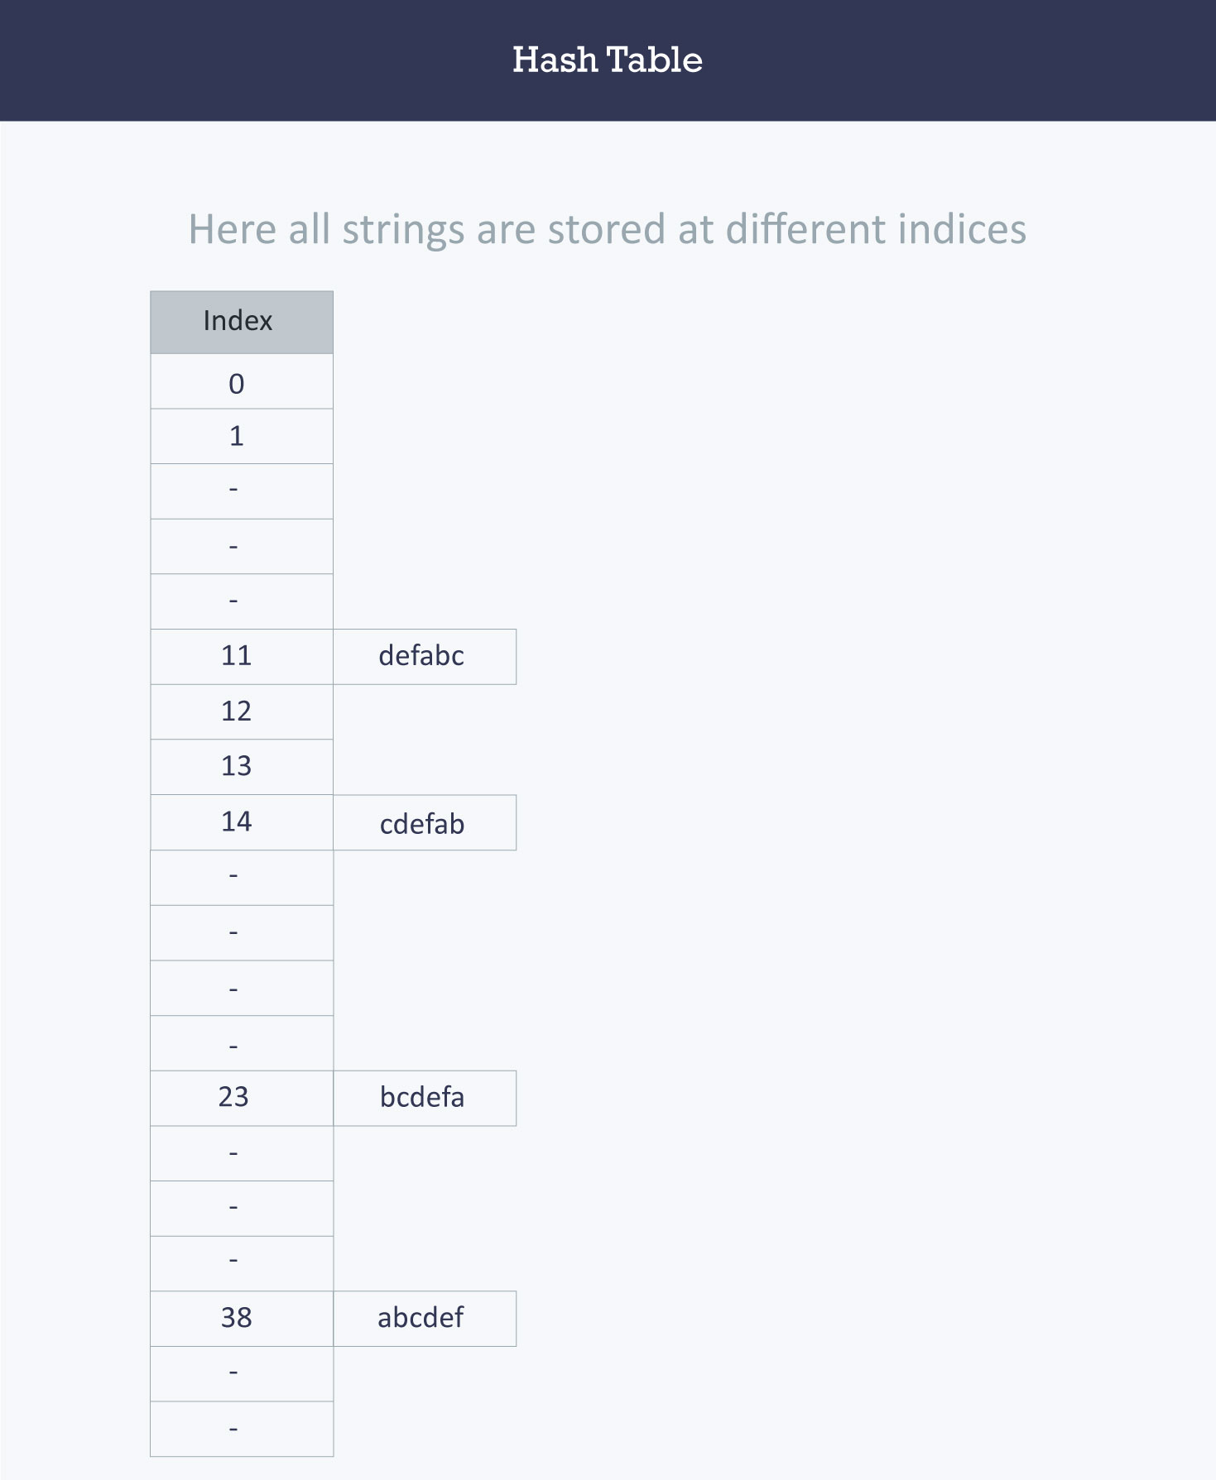

**Hash table**  
A hash table is a data structure that is used to store keys/value pairs. It uses a hash function to compute an index into an array in which an element will be inserted or searched. By using a good hash function, hashing can work well. Under reasonable assumptions, the average time required to search for an element in a hash table is **O(1)**.

Let us consider string S. You are required to count the frequency of all the characters in this string.

string S = “ababcd”

The simplest way to do this is to iterate over all the possible characters and count their frequency one by one. The time complexity of this approach is **O(26*N)** where **N** is the size of the string and there are 26 possible characters.

void countFre(string S)

{

for(char c = ‘a’;c <= ‘z’;++c)

{

int frequency = 0;

for(int i = 0;i < S.length();++i)

if(S[i] == c)

frequency++;

cout << c << ‘ ‘ << frequency << endl;

}

}

**Output**

a 2

b 2

c 1

d 1

e 0

f 0

…

z 0

Let us apply hashing to this problem. Take an array frequency of size 26 and hash the 26 characters with indices of the array by using the hash function. Then, iterate over the string and increase the value in the frequency at the corresponding index for each character. The complexity of this approach is **O(N)** where **N** is the size of the string.

int Frequency[26];

int hashFunc(char c)

{

return (c - ‘a’);

}

void countFre(string S)

{

for(int i = 0;i < S.length();++i)

{

int index = hashFunc(S[i]);

Frequency[index]++;

}

for(int i = 0;i < 26;++i)

cout << (char)(i+’a’) << ‘ ‘ << Frequency[i] << endl;

}

**Output**

a 2

b 2

c 1

d 1

e 0

f 0

…

z 0

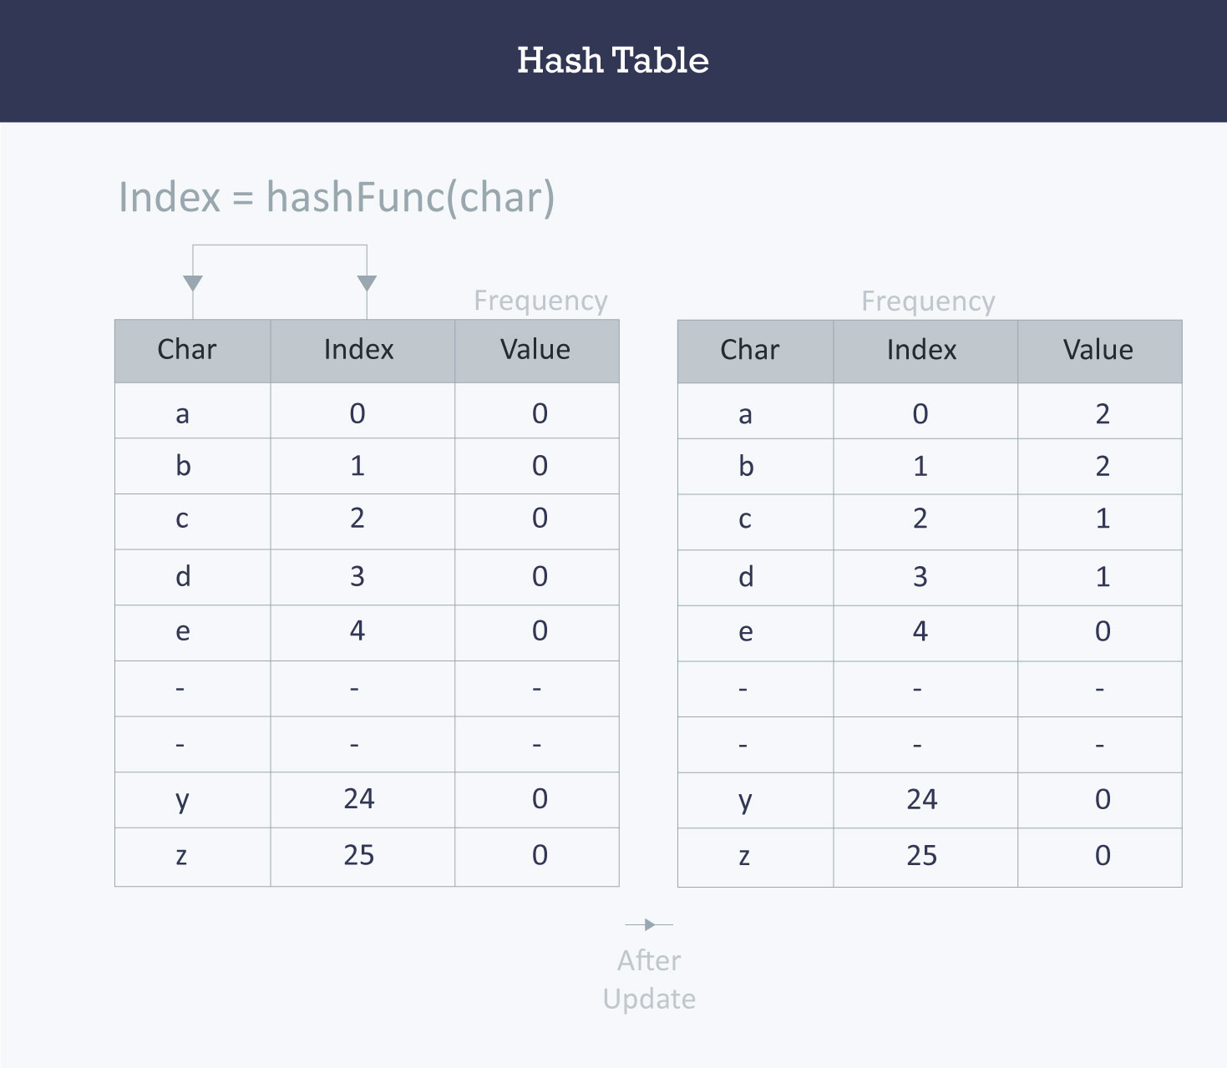

**Collision resolution techniques**

*Separate chaining (open hashing)*

Separate chaining is one of the most commonly used collision resolution techniques. It is usually implemented using linked lists. In separate chaining, each element of the hash table is a linked list. To store an element in the hash table you must insert it into a specific linked list. If there is any collision (i.e. two different elements have same hash value) then store both the elements in the same linked list.

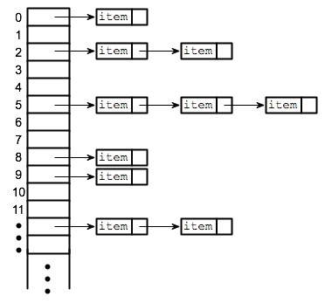

The cost of a lookup is that of scanning the entries of the selected linked list for the required key. If the distribution of the keys is sufficiently uniform, then the average cost of a lookup depends only on the average number of keys per linked list. For this reason, chained hash tables remain effective even when the number of table entries (N) is much higher than the number of slots.

For separate chaining, the worst-case scenario is when all the entries are inserted into the same linked list. The lookup procedure may have to scan all its entries, so the worst-case cost is proportional to the number (N) of entries in the table.

In the following image, **CodeMonk** and **Hashing** both hash to the value **2**. The linked list at the index **2** can hold only one entry, therefore, the next entry (in this case **Hashing**) is linked (attached) to the entry of **CodeMonk**.

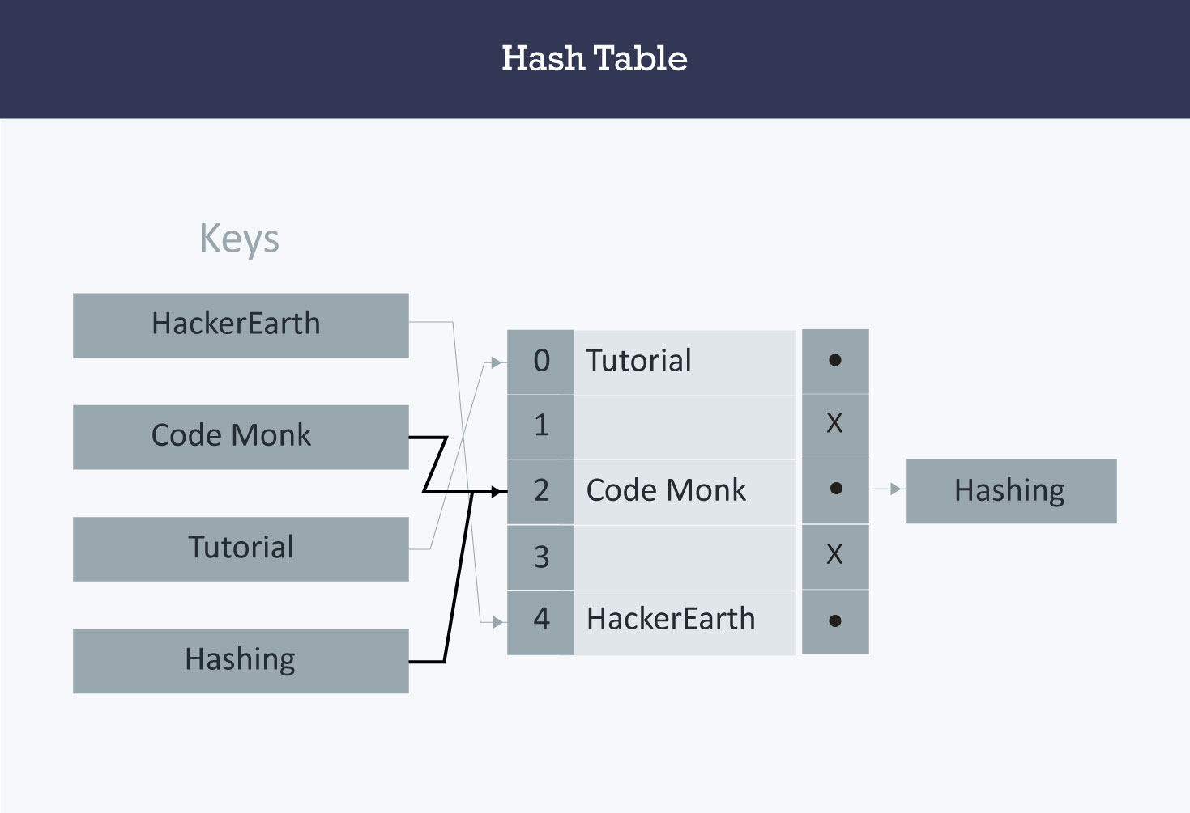

***Implementation of hash tables with separate chaining (open hashing)***

*Assumption*

Hash function will return an integer from 0 to 19.

vector <string> hashTable[20];

int hashTableSize=20;

*Insert*

void insert(string s)

{

// Compute the index using Hash Function

int index = hashFunc(s);

// Insert the element in the linked list at the particular index

hashTable[index].push_back(s);

}

*Search*

void search(string s)

{

//Compute the index by using the hash function

int index = hashFunc(s);

//Search the linked list at that specific index

for(int i = 0;i < hashTable[index].size();i++)

{

if(hashTable[index][i] == s)

{

cout << s << " is found!" << endl;

return;

}

}

cout << s << " is not found!" << endl;

}

***Linear probing (open addressing or closed hashing)***

In open addressing, instead of in linked lists, all entry records are stored in the array itself. When a new entry has to be inserted, the hash index of the hashed value is computed and then the array is examined (starting with the hashed index). If the slot at the hashed index is unoccupied, then the entry record is inserted in slot at the hashed index else it proceeds in some probe sequence until it finds an unoccupied slot.

The probe sequence is the sequence that is followed while traversing through entries. In different probe sequences, you can have different intervals between successive entry slots or probes.

When searching for an entry, the array is scanned in the same sequence until either the target element is found or an unused slot is found. This indicates that there is no such key in the table. The name "open addressing" refers to the fact that the location or address of the item is not determined by its hash value.

Linear probing is when the interval between successive probes is fixed (usually to 1). Let’s assume that the hashed index for a particular entry is **index**. The probing sequence for linear probing will be:

index = index % hashTableSize  
index = (index + 1) % hashTableSize  
index = (index + 2) % hashTableSize  
index = (index + 3) % hashTableSize

and so on…

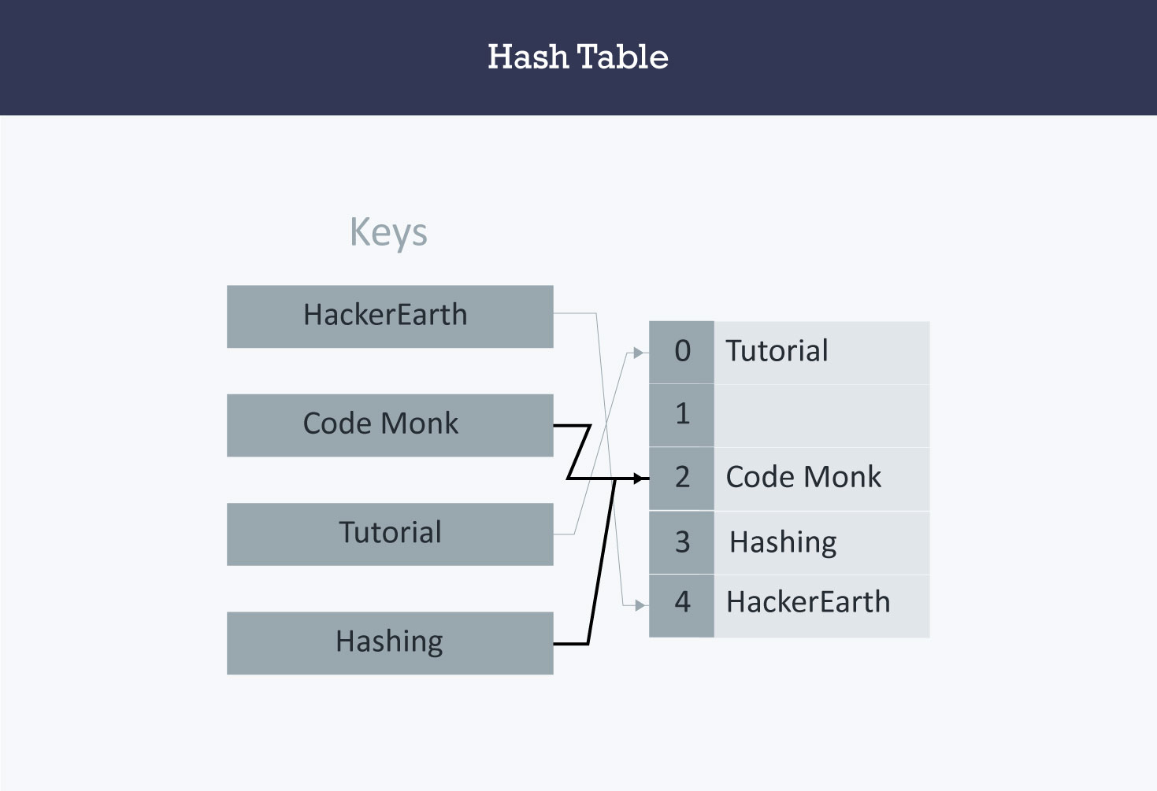

Hash collision is resolved by open addressing with linear probing. Since **CodeMonk** and **Hashing** are hashed to the same index i.e. **2**, store **Hashing** at **3** as the interval between successive probes is **1**.

***Implementation of hash table with linear probing***

*Assumption*

* There are no more than 20 elements in the data set.
* Hash function will return an integer from 0 to 19.
* Data set must have unique elements.

string hashTable[21];

int hashTableSize = 21;

*Insert*

void insert(string s)

{

//Compute the index using the hash function

int index = hashFunc(s);

//Search for an unused slot and if the index will exceed the hashTableSize then roll back

while(hashTable[index] != "")

index = (index + 1) % hashTableSize;

hashTable[index] = s;

}

*Search*

void search(string s)

{

//Compute the index using the hash function

int index = hashFunc(s);

//Search for an unused slot and if the index will exceed the hashTableSize then roll back

while(hashTable[index] != s and hashTable[index] != "")

index = (index + 1) % hashTableSize;

//Check if the element is present in the hash table

if(hashTable[index] == s)

cout << s << " is found!" << endl;

else

cout << s << " is not found!" << endl;

}

**Quadratic Probing**

Quadratic probing is similar to linear probing and the only difference is the interval between successive probes or entry slots. Here, when the slot at a hashed index for an entry record is already occupied, you must start traversing until you find an unoccupied slot. The interval between slots is computed by adding the successive value of an arbitrary polynomial in the original hashed index.

Let us assume that the hashed index for an entry is **index** and at **index** there is an occupied slot. The probe sequence will be as follows:

index = index % hashTableSize  
index = (index + 12) % hashTableSize  
index = (index + 22) % hashTableSize  
index = (index + 32) % hashTableSize

and so on…

***Implementation of hash table with quadratic probing***

*Assumption*

* There are no more than 20 elements in the data set.
* Hash function will return an integer from 0 to 19.
* Data set must have unique elements.

string hashTable[21];

int hashTableSize = 21;

**Insert**

void insert(string s)

{

//Compute the index using the hash function

int index = hashFunc(s);

//Search for an unused slot and if the index will exceed the hashTableSize roll back

int h = 1;

while(hashTable[index] != "")

{

index = (index + h*h) % hashTableSize;

h++;

}

hashTable[index] = s;

}

**Search**

void search(string s)

{

//Compute the index using the Hash Function

int index = hashFunc(s);

//Search for an unused slot and if the index will exceed the hashTableSize roll back

int h = 1;

while(hashTable[index] != s and hashTable[index] != "")

{

index = (index + h*h) % hashTableSize;

h++;

}

//Is the element present in the hash table

if(hashTable[index] == s)

cout << s << " is found!" << endl;

else

cout << s << " is not found!" << endl;

}

**Double hashing**

Double hashing is similar to linear probing and the only difference is the interval between successive probes. Here, the interval between probes is computed by using two hash functions.

Let us say that the hashed index for an entry record is an index that is computed by one hashing function and the slot at that index is already occupied. You must start traversing in a specific probing sequence to look for an unoccupied slot. The probing sequence will be:

index = (index + 1 * indexH) % hashTableSize;  
index = (index + 2 * indexH) % hashTableSize;

and so on…

Here, **indexH** is the hash value that is computed by another hash function.

**Implementation of hash table with double hashing**

*Assumption*

* There are no more than 20 elements in the data set.
* Hash functions will return an integer from 0 to 19.
* Data set must have unique elements.

string hashTable[21];

int hashTableSize = 21;

**Insert**

void insert(string s)

{

//Compute the index using the hash function1

int index = hashFunc1(s);

int indexH = hashFunc2(s);

//Search for an unused slot and if the index exceeds the hashTableSize roll back

while(hashTable[index] != "")

index = (index + indexH) % hashTableSize;

hashTable[index] = s;

}

**Search**

void search(string s)

{

//Compute the index using the hash function

int index = hashFunc1(s);

int indexH = hashFunc2(s);

//Search for an unused slot and if the index exceeds the hashTableSize roll back

while(hashTable[index] != s and hashTable[index] != "")

index = (index + indexH) % hashTableSize;

//Is the element present in the hash table

if(hashTable[index] == s)

cout << s << " is found!" << endl;

else

cout << s << " is not found!" << endl;

}

**Applications**

* *Associative arrays*: Hash tables are commonly used to implement many types of in-memory tables. They are used to implement associative arrays (arrays whose indices are arbitrary strings or other complicated objects).
* *Database indexing*: Hash tables may also be used as disk-based data structures and database indices (such as in dbm).
* *Caches*: Hash tables can be used to implement caches i.e. auxiliary data tables that are used to speed up the access to data, which is primarily stored in slower media.
* *Object representation*: Several dynamic languages, such as Perl, Python, JavaScript, and Ruby use hash tables to implement objects.
* Hash Functions are used in various algorithms to make their computing faster

*Contributed by: Prateek Garg*

**Did you find this tutorial helpful?**

 YES

 NO

**TEST YOUR UNDERSTANDING**

**Name Lookup**

Our friend Monk has been made teacher for the day today by his school professors . He is going to teach informatics to his colleagues as that is his favorite subject . Before entering the class, Monk realized that he does not remember the names of all his colleagues clearly . He thinks this will cause problems and will not allow him to teach the class well. However, Monk remembers the roll number of all his colleagues very well . Monk now wants you to help him out. He will initially give you a list indicating the name and roll number of all his colleagues. When he enters the class he will give you the roll number of any of his colleagues belonging to the class. You need to revert to him with the name of that colleague.

**Input Format**

The first line contains a single integers *N* denoting the number of Monk's colleagues. Each of the next *N* lines contains an integer and a String denoting the roll number and name of the *i* th colleague of Monk. The next Line contains a single integer *q* denoting the number of queries Monk shall present to you when he starts teaching in class. Each of the next *q* lines contains a single integer *x* denoting the roll number of the student whose name Monk wants to know.

**Output Format**

You need to print *q* Strings, each String on a new line, indicating the answers to each of Monk's queries.

**Constrains**

1≤N≤105

1≤RollNumber≤109

1≤|Name|≤25

1≤q≤104

1≤x≤109

**Note**

The name of each student shall consist of lowercase English alphabets only. It is guaranteed that the roll number appearing in each query shall belong to some student from the class.